JPMorgan QR Mentorship Program 2024 Case Study

Time series analysis and Stock Market Prediction

**Suggested Format**

This is a challenge with mostly open-ended questions to guide your through the process of predicting stock time series using statistical models.

You are free to use online resources and discuss with your mentor and fellow mentees to improve your understanding of the problem statement.

As you work on the problems, you will discuss your progress with your mentor and ask for feedback on your solutions. We will not grade your submissions however we expect you to be proactive in solving problems, discussing ideas, and soliciting feedback to learn and grow.

**Solution & Question Submissions**

Please submit your final solution to ***QR_NA_Mentorship_Program_External@jpmchase.com*** with“***JPM QR Mentorship Case Study Submission <FirstName_LastName>”*** in your email subject.

Office hours and support for this Case Study will end **July 15th** so we encourage you to complete this case study within the allotted time.

You are welcome to submit your case-study related questions to ***QR_NA_Mentorship_Program_External@jpmchase.com.*** Please use the format “***JPM QR Mentorship Case Study Question <FirstName_LastName>”*** in your email subject.

**Problem Statement Overview**

Time Series data is a series of data points indexed in time order. Time series data is everywhere, so manipulating them is important for any data analyst or data scientist.

In this notebook, we will discover and explore data from the stock market, particularly some technology stocks. We will learn how to use yfinance to get stock information and visualize different aspects of it using Seaborn and Matplotlib. we will look at a few ways of analyzing the risk of a stock, based on its previous performance history. We will also be predicting future stock prices through a Long Short-Term Memory (LSTM) method!

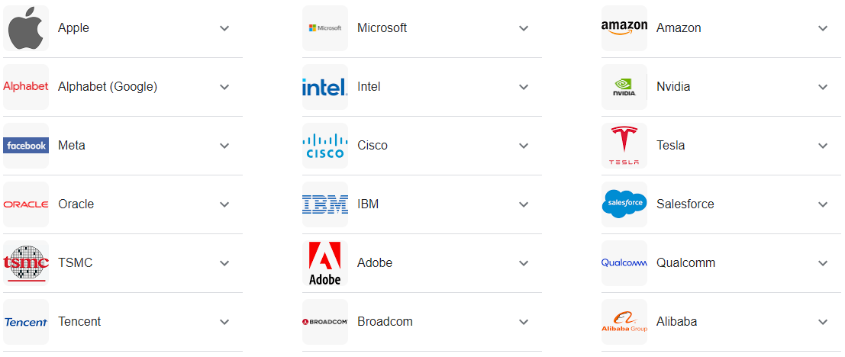

We'll be answering the following questions along the way:

1.) What was the change in price of the stock over time?

2.) What was the daily return of the stock on average?

3.) What was the moving average of the various stocks?

4.) What was the correlation between different stocks?

5.) How much value do we put at risk by investing in a particular stock?

6.) How can we attempt to predict future stock behavior? (e.g. predicting the closing price stock price of APPLE inc using LSTM)

Reference: <https://machinelearningmastery.com/lstm-for-time-series-prediction-in-pytorch/>

Be aware of the number of parameters in your model and decide how many training data you are going to use. List the techniques you used to prevent overfitting if there is any.

7) Suppose we have a derivative maturing in 5 trading days, with payoff function f(x) where f is some given function and x is the closing price at maturity date. How could we use/modify our model to estimate its payoff ?

8) How can you make Neural Network model (e.g. LSTM) more interpretable?

**Getting the Data**

The first step is to get the data and load it to memory. We will get our stock data from the Yahoo Finance website. Yahoo Finance is a rich resource of financial market data and tools to find compelling investments. To get the data from Yahoo Finance, we will be using yfinance library which offers a threaded and Pythonic way to download market data from Yahoo. Check this article to learn more about yfinance: [Reliably download historical market data from with Python](https://aroussi.com/post/python-yahoo-finance)